Mapping Function website

## E.g. Rhondda Cynon Taff

1. Bot will populate the address, find the address and click on dropped pin to reveal application details at that location

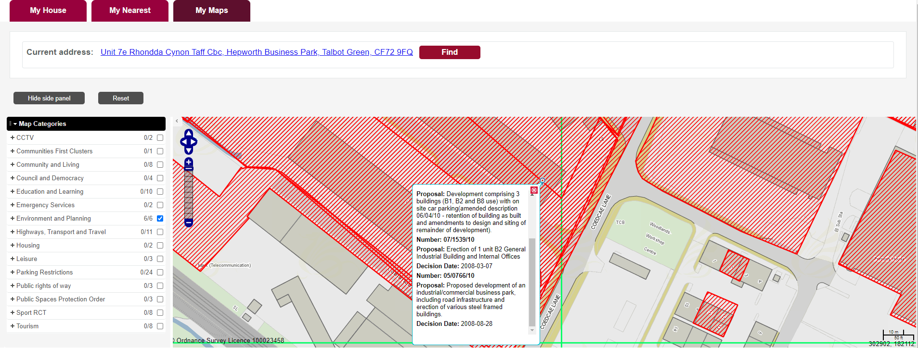

1. Now the Planning applications fields are shown as per below screenshot

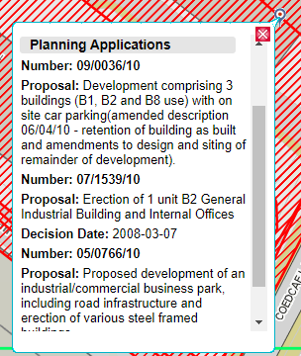

1. So Bot has extracted all the details available in the planning applications

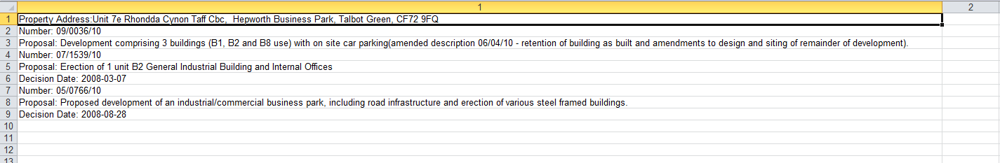

# The Planning applications are also similar to the websites like

1. Cardiff
2. Newport
3. Vale of Galmorgan
4. Carmarthenshire

#### Cardiff:

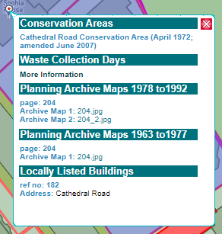

#### Newport:

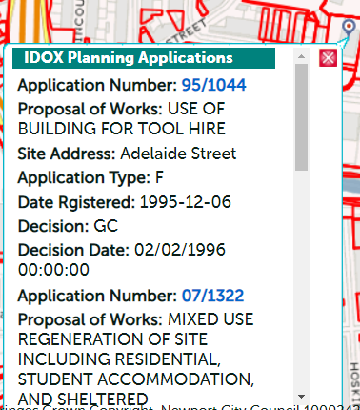

#### Vale of Glamorgan:

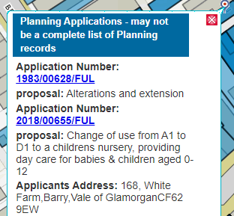

#### Carmarthenshire:

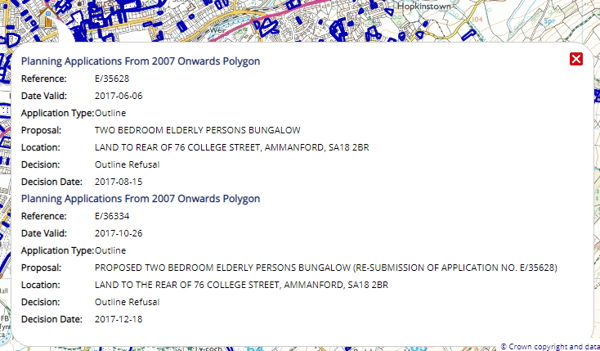

# Questions:

1. What are the fields does the bot need to extract form these websites Planning application?
2. Is it ok to extract every information form these websites Planning application?

Responses:

1. Essential fields to be collected for all websites as follows:

Reference

Proposal

Location

Decision

Decision Date

Data collected on attached spreadsheet does look good, some have a little too much data, but this can be tidied up in house, if required.

Spacing of applications is an issue as they are difficult to read, an empty field/row between each application would make this much easier to decipher.